Homework Feedback 2

2010/10/18

Weiwei Xu

**P. 54 #13** Use Theorem 2.1 to find a bound for the number of iterations needed to achieve an approximation with accuracy 10^-4 to the solution of x^3 – x - 1 = 0

The answers in the submitted homework reports are correct: 14 iterations, the root 1.32477…

Typical error：

Two students compute the root of x^3 + x - 4 = 0 in problem #12

**P.54 #15** Let $p_{n}$ be the sequence defined by $p_{n}=\sum_{k=1}^{n}{\frac{1}{k}}$. Show that $p_{n}$ diverges even though ${\lim_{n→∞}{p}}_{n}-p_{n-1}=0$.

The answers in the submitted homework reports are correct.

**P.64 #3** The following four methods are proposed to compute ${21}^{\frac{1}{3}}$. Rank them in order. based on their apparent speed of convergence. assuming $p_{0}=1$.

Answer: c does not converge. The convergence speed order: b>d>a.

Note: The theorem 2.3 is the sufficient condition but not the necessary condition of the fixed point convergence. You can also use the problem in P.64 #19 as an example.

Typical errors:

1. Only calculate the derivative of the fixed point iteration at $p_{0}=1$.
2. There also exist errors in the derivation, for example:

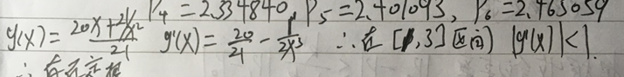

**P.64 #19** a. Use Theorem 2.3 to show that the sequence defined by $x_{n}=\frac{1}{2}x_{n-1}+\frac{1}{x_{n-1}}$ converges to $\sqrt{2}$ whenever $x_{0}>\sqrt{2}$.

b. Use the fact that ${\left(x_{0}-\sqrt{2}\right)}^{2}>0$ whenever $x_{0}≠\sqrt{2}$ to show that if $0<x_{0}<\sqrt{2}$, then

$x_{1}>\sqrt{2}$.

c. Use the results of parts (a) and (b) to show that the sequence in (a) converges to $\sqrt{2}$

whenever $x_{0}>0$.

The answers in the submitted homework reports are correct.

Typical error:

1. There exists incorrect or indirect proof of (b). The proof is simple as shown in the following figures:

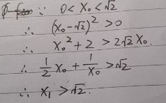

or

